MXL100 EXCELL SPREADSHEET TEST PAPER

Name ____________________________________

Class: _______________________ Date ___________________

Time allowed 1 hour, allowed pens, calculator

Question | Available Mark | Your Mark
1- 6 | 6
7 | 3
8 | 1
9 | 2
10 | 2
11 | 2
12 | 2
13 | 2
14 | 7
15 | 8
16 | 1
17 | 1
18 | 5
19 | 16
20 | 12
21 | 1
22 | 4
Total | 75

Circle your answer (multiple Choice) or give written answers where required

- A spreadsheet is a software package that
a. resembles a table and is used for organizing numbers
b. resembles a table and is used for database fields
c. resembles a table and is used for making calculations
d. all of the above
(1 mark)
2. An electronic spreadsheet file can contain as many as __???__ worksheets.
a. 125
b. 255
c. 225
d. 155
(1 mark)
3. Columns and rows are used __???__.
a. as a formatting feature
b. for printing purposes
c. to organize data or information in a spreadsheet
d. for adding or inputting data
(1 mark)

4. Cells are referenced by __???__.
a. column letter and row number
b. row label
c. labels defined by the user
d. column label
(1 mark)

5. When you change values in a spreadsheet, formulas are __???__ automatically.
a. removed
b. copied to an adjacent cell
c. recalculated
d. copied to another spreadsheet
(1 mark)

6. Columns are identified by __???___.
a. letters ranging from A to IV
b. numbers from 1 to 256
c. letters from A to Z and numbers from 1 to 230
d. numbers from 1 to 230 and letters from A to Z
(1 mark)

General Questions

7. List three types of data you can enter into a cell.

a. ______________

b. ______________

c. ______________
(3 marks)

8. An Excel worksheet cell can contain text, values, formula, and _____________ entries.
(1 mark)

9. You could write the formula =B4+B5+B6+C4+C5+C6 to sum values in the six cells, but the SUM function is a better solution. The SUM function to sum the preceding six cells is_____________
(2 marks)

10. You can store an Excel workbook on disk by executing the File menu then _____________ or _____________
(2 marks)

11. To empty the contents of a worksheet cell, right-click the cell and
then click _____________ on the pop-up menu.
(2 marks)

12. The ability to type into worksheet cells different values and see their effect on a worksheet is called ______________ analysis.
(2 marks)
13. A worksheet ______________ appears on the top of each printed Worksheet page.
(2 marks)

14. Indicate which of the following cell entries are text, values, or formulas.

- =A1+B2
- 11/12/02
- 42,350
- Sum(Al:B2)
- 1st Quarter Sales
- 401-555-1212
- = 11/12/19
(7 marks)
15. List eight functions that come built-in with spreadsheet programs.

a. | e.
b. | f.
c. | g.
d. | h.
(8 marks)
16. What-if analysis is a powerful tool for testing the impact of changing values in a formula. True or False? ______________
(1 mark)

17. A spreadsheet can convert numerical calculations into charts and graphs to show relationships graphically. True or False? ______________

(1 mark)

18. In a spreadsheet, shown cell A7 shows $157.00 the formula in cell C7 =$A7
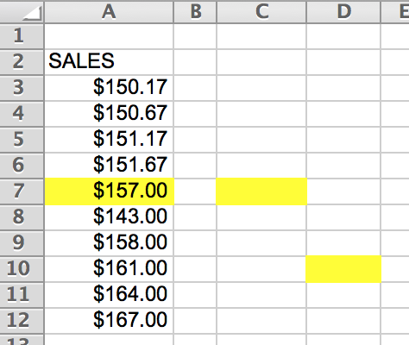
(a) What would the formula (and the result) be? And why?
Formula _________________

Result ___________________

Why ___________________________________
(b) What would the formula be if it were pasted into D10?
Formula _________________
Result _______________________________ (5 marks)

19. At teacher at Hell School, Mrs Maelstrom, keeps her exam results on a spreadsheet to help her do the calculations.
 |  | I | J | K | L | M | N
 | 10 | Mrs Maelstrom’s First Semester Exam results
 | 11
 | 12 |  | Part A | Part B | Part C | Total | Rank
 | 13 | Joybelle | 10 | 27 | 15
 | 14 | Karlon | 13 | 32 | 20
 | 15 | Lucille | 11 | 21 | 14
 | 16 | Maximillian | 14 | 19 | 23
 | 17 | Noreen | 9 | 22 | 19
 | 18 | Orestes | 10 | 24 | 23
 | 19 | ------------- | ------------- | ------------- | ------------- | ------------- | -------------
 | 20 | Average | 11.1667 | 24.17 | 19.
 | 21

- Mrs Maelstrom wants to enter a formula in to cell M13 to add up the three parts of the exam. Suggest a good formula.
______________
(3 marks)
(b) Being an Excel novice, Mrs Maelstrom is not sure whether she should have used absolute addressing or relative addressing in cell M13 if she is to fill the column down.
Which would be the best to use?
______________
(2 marks)
(c) What formula should Mrs Maelstrom put into cell M20?
______________
(2 marks)

(d) Mrs Maelstrom wants to get a rank, in descending order of total exam marks in column N.
What range of cells should she select before using the Excel sort data operation?
_______________________________________________________________________
(3 marks)

(e) Which student will be at the top of the class when Mrs Maelstrom ranks the class in descending order of total score, after having sorted it on column M?
________________________________________________________________
(2 marks)

(f) Which student will be at the bottom of the class when Mrs Maelstrom ranks the class in descending order of total score?
_______________________________________________________________
(2 marks)

(g) The present formatting of the average is rather inelegant (dodgy?). How can this be improved?
________________________________________________________________
(2 marks)

20. Study the spreadsheet below then answer the questions about it.
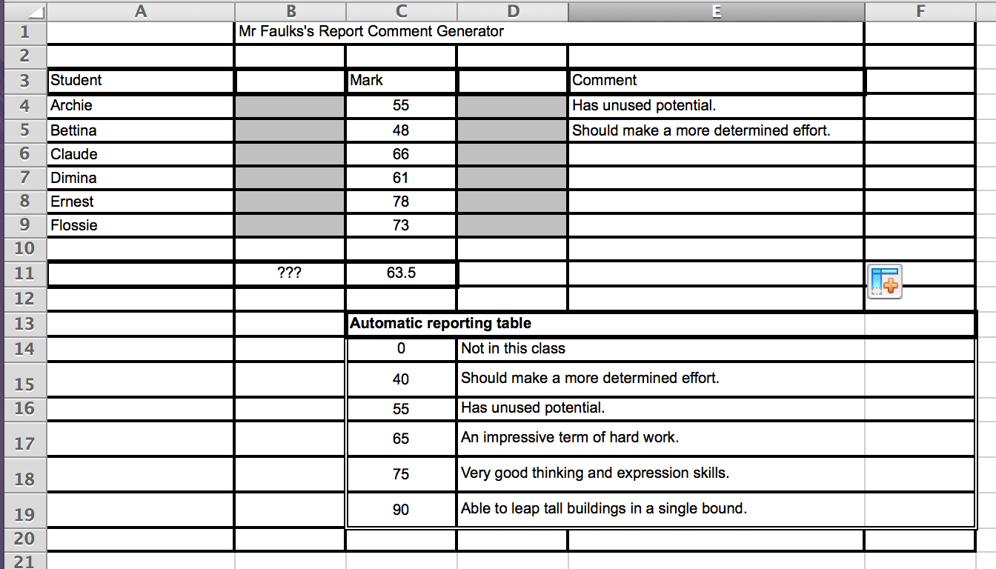
(a) What kind of formula would have been used to get the comments for Archie and Bettina to be automatically inserted, based on the mark they got, and the table at the bottom of the sheet?
(Just give the general idea in your own words. No need to give the exact formula.)
______________________________________________________________________
(3 marks)
(b) What text probably refers to the cell B11?
_______________________________________________________________________
(3 marks)

(c) What formula is most likely to be in cell C11?
_______________________________________________________________________
(3 marks)
(d) Write down the full details (in your own words is acceptable) of the formula that is most probably in cell E4.
________________________________________________________________________
(3 marks)

21. Excel Spreadsheet can be used as a database

True / False ______________

(1 mark)

22. On the Spreadsheet diagram below show:

(a) a row

(b) a column

(c) one cell

(d) a range of cells

Draw on the picture-shaded areas and use arrows to show

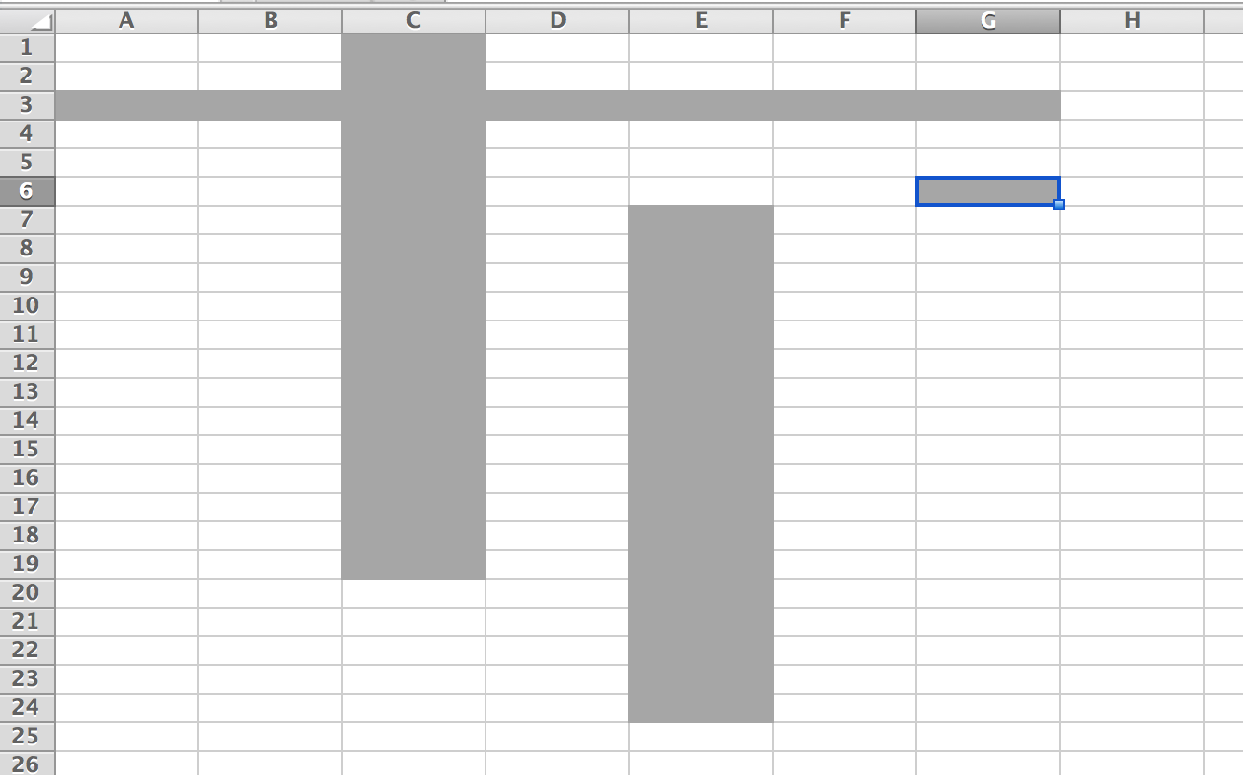
(4 marks)

END OF TEST

